J2ME Sample Game 4 – Sweep Game

Screenshot

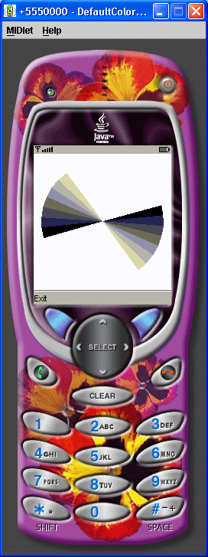

Source Code

/*
Wireless Java 2nd edition
Jonathan Knudsen
Publisher: Apress
ISBN: 1590590775
*/
import javax.microedition.lcdui.*;
import javax.microedition.lcdui.game.*;
import javax.microedition.midlet.*;
public class SweepGame extends MIDlet {
public void startApp() {
final SweepGameCanvas sweeper = new SweepGameCanvas();
sweeper.start();
sweeper.addCommand(new Command("Exit", Command.EXIT, 0));
sweeper.setCommandListener(new CommandListener() {
public void commandAction(Command c, Displayable s) {
sweeper.stop();
notifyDestroyed();
}
});
Display.getDisplay(this).setCurrent(sweeper);
}
public void pauseApp() {}
public void destroyApp(boolean unconditional) {}
}
class SweepGameCanvas extends GameCanvas implements Runnable {
private boolean mTrucking;
private int mTheta;
private int mBorder;
private int mDelay;
public SweepGameCanvas() {
super(true);
mTheta = 0;
mBorder = 10;
mDelay = 50;
}
public void start() {
mTrucking = true;
Thread t = new Thread(this);
t.start();
}
public void stop() {
mTrucking = false;
}
public void render(Graphics g) {
int width = getWidth();
int height = getHeight();
// Clear the Canvas.
g.setGrayScale(255);
g.fillRect(0, 0, width - 1, height - 1);
int x = mBorder;
int y = mBorder;
int w = width - mBorder * 2;
int h = height - mBorder * 2;
for (int i = 0; i < 8; i++) {
g.setGrayScale((8 - i) * 32 - 16);
g.fillArc(x, y, w, h, mTheta + i * 10, 10);
g.fillArc(x, y, w, h, (mTheta + 180) % 360 + i * 10, 10);
}
}
public void run() {
Graphics g = getGraphics();
while (mTrucking) {
mTheta = (mTheta + 1) % 360;
render(g);
flushGraphics();
try { Thread.sleep(mDelay); }
catch (InterruptedException ie) {}
}
}
}

